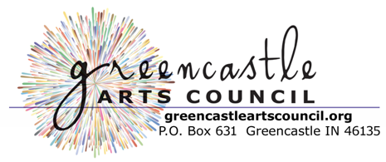
The purpose of the We Art Putnam County Banner Campaign contest is to encourage and celebrate young artists and highlight the unique qualities of Putnam County. The GAC is sponsoring this project and will provide the graphic services needed to print the winning designs from each school district onto banners. Banners will become property of the City of Greencastle. There is no cost to enter.

GUIDELINES:
- Any middle school age student residing in Putnam County (IN) is eligible to enter.
- All entries must be of an original design and must not infringe upon or violate the intellectual property rights of any other person or entity.
- Entries are due Friday, April 30th by noon to be eligible for consideration. Artwork will be picked up from each Putnam County middle school and the Putnam County Public Library on that day by a GAC representative.
- Each entry must include:
  - Artist’s Full Name
  - Artist’s Age
  - Parent/Guardian Contact Information (including phone and email)
  - School District of Residence and teacher’s name, OR labeled PCPL entry.
  - All submissions must be 9”x12” and oriented as a portrait.
  - Artwork should fill the entire page: top, bottom and both sides.
  - Must highlight subject matter that is unique to Putnam County, IN.
- Entries can be any medium. While any medium may be used, simple designs that are bold with clearly defined lines will translate more successfully to the required format to print a light pole banner.
- One entry per person.
- The artist remains the legal owner of all rights contained in the submission. However, the GAC reserves the right to use entries for their promotional publications and on social media platforms.
- The GAC may refuse any entry that it deems inappropriate.
- All artwork will be judged by a panel of professional artists. The jury’s decision is final.
- Entries will be returned by Friday, May 14th, 2021, to each of the Putnam County middle schools and the Putnam County Public Library.

For more information, please email the Greencastle Arts Council at gacsubmission@gmail.com and use “Banner Contest” as the subject line.

We want to let others know why Putnam County (IN) is a great place to visit. What would you like visitors to see? Some favorite locations, attractions, and activities to consider: local buildings, landmarks, parks, playgrounds, and waterways; Activities, Events, and Festivals such as the PC Playhouse, the Farmer's Market, County Fair, (local) concerts, etc; Natural attractions such as wildlife, agriculture, livestock, and landscapes; important places you may visit regularly such as your school’s campus, IvyTech or DePauw University campuses and/or Nature Park, McKim Observatory; etc.

